ICCW2024 - CONFERENCE PROGRAMME
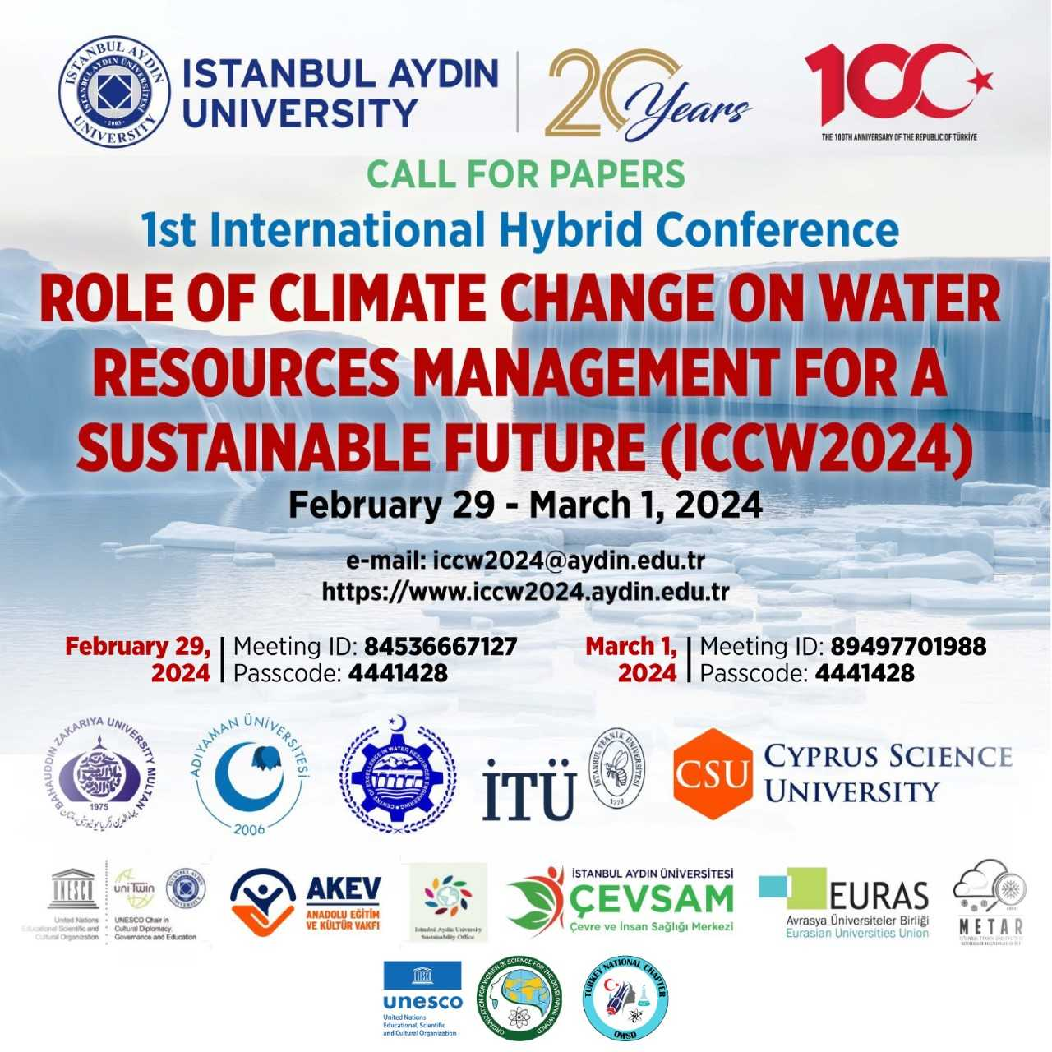
_________________________________________________
DAY-1: February 29, 2024 9.15-13.00 local / 6.15-10.00GMT
ONLINE LINK FEBRUARY 29, 2024
Zoom | 1st International Hybrid Conference ROLE OF CLIMATE CHANGE ON WATER RESOURCES MANAGEMENT FOR A SUSTAINABLE FUTURE
Zoom Type | Zoom Webinar
Zoom ID | 84536667127
Password | 4441428
Zoom Link | https://us06web.zoom.us/j/84536667127?pwd=Hz8uaKLcaApDLd4vKcar4FpkaihU7D.1
Reservation | 29.02.2024 09:00 | 29.02.2024 18:00
7.00-11.00 GMT /09.00-13.00 local: REGISTRATION, ICEC-SAPHIRE HALL
6.15 –6.30 GMT 29 February 2024
9.15- 9.30 Local WELCOME REMARKS
President, IAU; Rector IAU, ITU, Adıyaman Univ., Gn. Director TMS, Ankara
Session 1: Climate Change Strategies and Policies
Chair(s): Ali SINAĞ, Rashmi BHARDWAJ
6.30 -7.30 GMT  9.30-10.30 Local | Invited Speaker: Water, Water Everywhere! A Systemic Approach to Sustainability Knowledge & Assessment. Scott G. BLAIR, TASK France
6.30 -7.30 GMT  9.30-10.30 Local | Water Management in Punjab, Pakistan with community participation: A step towards sustainable water use. Saira AKHTAR, Sobia MAQSOOD, E. ASHRAF, UAF, Pakistan.
6.30 -7.30 GMT  9.30-10.30 Local | Rainwater Management Policies in İstanbul: A Comparable Analysis. Zelha ALTINKAYA, Yalova University, Türkiye
7:30 - 8.00 GMT BREAK / GROUP PHOTO
10.30 -11.00 Local
Session 2: Water Resources AnalysisTools and Techniques
Chair(s): Sajid MAHMOOD, Eman EL-SARAAG
8:00-9:30 GMT  11:00-12:30 Local | Invited Speaker: A Sustainable Water and Mineral Recovery Technology: Eutectic Freeze Crystallization, Elif GENCELİ GÜNER, İTÜ, Türkiye
8:00-9:30 GMT  11:00-12:30 Local | Invited Speaker: Artificial Intelligence Wavelet Conjunction Fractal Analysis of Water Quality Bhardwaj, RASHMI, GGSIPU, Delhi, India
8:00-9:30 GMT  11:00-12:30 Local | Assessing River Flow Patterns in the Context of Climate Change: A Machine Learning Framework Vinita Sangwan, Rashmi BHARDWAJ GGSIPU, India
8:00-9:30 GMT  11:00-12:30 Local | Application of EM with Machine learning approach for the estimation of water quality parameters. S. Garg, R. BHARDWAj, GGSIPU, Delhi, India
8:00-9:30 GMT  11:00-12:30 Local | Investigation of Extreme Weather Events: Istanbul International Airports Example. R. Yimit, E.Tuncay ÖZDEMIR, İTÜ, Istanbul, Türkiye
8:00-9:30 GMT  11:00-12:30 Local | Possible Changes in Evapotranspiration Under the Influence of Climate Change in Selected Provinces of Türkiye. M. AZLAK, Levent ŞAYLAN, İTÜ, Istanbul, Türkiye
8:00-9:30 GMT  11:00-12:30 Local | Contribution by Students Club: ITU Club – METAR, Yaren KÖSE
General Evaluation
Chair(s): Chair(s): Levent SAYLAN, Celal N. İREM
9:30-10:00 GMT 12:30-13:00 Local | Discussion on joint research programs, applications and publication / a network like UNIMED, to briefly mention what UNIMED is doing in this perspective and to encourage a stronger partnership among research and education actors in the MED Region, Marcello SCALISI, Director UNIMED, Rome, Italy

DAY-2: March 01, 2024, 9.00-18.15 local / 6.00-11.00 GMT
IAU T BLOCK-1, PURPLE HALL
ONLINE LINK MARCH 01, 2024
Zoom |  | 1st International Hybrid Conference ROLE OF CLIMATE CHANGE ON WATER RESOURCES MANAGEMENT FOR A SUSTAINABLE FUTURE
Zoom Type |  | Zoom Webinar
Zoom ID |  | 89497701988
Password |  | 4441428
Zoom Link |  | https://us06web.zoom.us/j/89497701988?pwd=wXxeCvySg2yIAoErOAJcAB4nc8ETxh.1
Reservation |  | 01.03.2024 09:00 | 01.03.2024 18:00
6.15 –6.30 GMT 01 March 2024
9.15- 9.30 Local WELCOME TO THE PARTICIPANT
President, IAU; Rector IAU, ITU, Adıyaman Univ., Gn. Director TMS, Ankara
Session 3: Technological Solutions for Agriculture and Water Use
Chair(s): Metin GER, Scott G. BLAIR
 |  |  | Invited Speaker: The atmospheric dynamics contributing to the occurrence of drought over North America and Eastern Europe, Anthony R. LUPO, University of Missouri, USA
 | 6.15 – 8.00 GMT  9.15-11.00 Local |  | Invited Speaker: Environmental threats to water-world and their control strategies, Jehangir K. SIAL, FAE&T, UAF, Pakistan
 |  |  | Invited Speaker: Scenarios of future changes in water stress under the influence of climate changes and increasing demands, Rovshen ABBASOV, Khazar University, Baku, Azerbaijan
 |  |  | Sensitivity Analysis of Physical Process and Simulation in WRF-ARW Model for Medicane in West of Türkiye. S. A. SIRDAS and Muhammet Mert ÇIRAK , İTÜ; Türkiye.
 |  |  | Global ramifications of inadequate solid waste management and its influence on climate change, Jasir Mushtaq & Zeyneb KILIC, Adiyaman University, Türkiye
 |  |  | Sustainable Water Management: Rainwater Harvesting, Vildan BAYRAM, Istanbul Aydın University, ABMYO, İstanbul, Türkiye
 |  |  | The Effect of Climate Change on Flood Water Levels, Burhan YILDIZ, Onur ATALIK, Aytun EKEROĞLU, Beyza Nur YUVALLI, Muğla Sıtkı Koçman University, Türkiye
8:00 - 8.30 GMT BREAK
11.00 -11.30 Local
Session 1.2 (Cont.): Climate Change Strategies and Policies
Chair(s): Eşref ADALI, Rovshen ABBASOV
 | 8.30 – 9.30 GMT  11.30-12.30 Local |  | Invited Speaker: High-resolution future SSP 8.5 scenario results over Türkiye: The impact of climate change on water budgets of snow-dominated basins, İsmail YÜCEL, METU, Ankara, Türkiye
 |  |  | The Potential of Olive Production in The Keçiborlu District. A. TOKGÖZLÜ, T. A. TIK, SDÜ, Isparta, Türkiye
 |  |  | Safran, the golden plant growed in the dry season, A. TOKGÖZLÜ and K. TEMURÇİN, SDÜ, Isparta, Türkiye
 |  |  | Impact of Varying Climatic Conditions on Irrigation Water Demand and Food Availability Kajal Chaudhary, Rashmi BHARDWAJ, USBAS, GGSIPU, Delhi, India
 |  |  | Assessment of Drought Risk and Adaptation Strategies to Climate Change in Tunceli: SPI and RDI Analysis, Meral KORKMAZ,¹ Munzur University, Tunceli, Türkiye.
 |  |  | Investigation of the climate change and meteorological drought in coastline of Eastern Black Sea Region, Barış AYDIN, Osman ÜÇÜNCÜ, TSM, Trabzon, Turkey.
9:30- 10.30 GMT LUNCH/ GROUP PHOTO
12.30-13.30 Local
Session 3.2 (cont.): Technological Solutions for Agriculture and Water Use
Chair(s): Kasım KOÇAK, , Sevinç A. SIRDAŞ
 | 10.30-12.00 GMT  13.30-15.00 Local |  | Invited Speaker: Climate change predictions over Türkiye and effects on water resources: Example of Euphrates Tigris river basin, Yurdanur S. ÜNAL, E. SALKIM İTÜ, İstanbul, T
 |  |  | Invited Speaker: Climate Change and Winter Drought, Naseer GILANI, DFI Pakistan
 |  |  | Purification of Industrial Water By Plants For Irrigation Purposes, Abida KAUSAR and Ayesha ATHER, Government College Women University Faisalabad, PAKİSTAN
 |  |  | Use of Straw Water Holder in Agriculture, Funda DÖKMEN, Kocaeli University, TÜRKİYE.
 |  |  | Influence of climate change conditions on phytomass production of perennial grass in and ecosystems of Tunisia, Lobna Mnif FAKHFAKH and Mohamed CHAIEB, Tunisia
 |  |  | Monitoring and Management of Groundwater in Pakistan for Sustainability of Agriculture and Rural Livelihood, Saira AKHTAR, Ghulam Zakir Hassan SIAL, IRI, Pakistan
 |  |  | Causes and Effects of Climate Change on Human Health, Agriculture, Food Security Muhammad Saeed, Sajid MAHMOOD, Sumera KHALID, Hafiz Abdur REHMAN, Zeyneb KILIÇ, Zafer ASLAN, Sarfaraz HASHIM, IWASRI, Pakistan
 |  |  | Review of Brain Treatment in Reverse Osmosis Deanilation Plants Utilinzing Membran Technologies, Oluwasen Emmanuel BABAJIDE, Mustafa Burak DOĞANAY, Aydın CIHANOĞLU, Mehmet Kamil MERIÇ, Nalan KABAY, Türkiye
12.00- 12.30 GMT BREAK
15.00 -15.30 Local
Session 4: Education and Awareness
Chair(s): Funda DÖKMEN, Hasan Hüseyin BALIK
 | 12.30-14.00 GMT  15.30-17.00 Local |  | Invited Speaker: Nature – Climate – Human Result: A case study on Lake Eğirdir, E. ADALI, İTÜ, İstanbul, Türkiye
 |  |  | Invited Speaker: Assessing environmental impacts of irrigation project water resources, in reservoir areas, Y. AHI, O. DENIZ, F. DÖKMEN, A.H. ORTA, University of Tekirdağ Namık Kemal, KOU, Türkiye
 |  |  | Education for Awareness on Climate Change and Water Resources Management around the Mediterranean Basin: Tunisia as an example, Mohamed F. KADHKADHI and S. KAMOUN-CHOUK University of Manouba, Tunisia,
 |  |  | Water Resources Management under Climate Change, Inderjeet, Rashmi BHARDWAJ USBAS, GGSIPU, Delhi, India
 |  |  | Evapotranspiration modelling for efficient water resources management: a comparative study of takagi-sugeno fuzzy system and generalized regression neural network models-case of study semiarid regions -Algeria , Assia MEZIANI University of El-Oued, Algeria
 |  |  | The Nexus of Climate Change and Economic Growth in the Cities Of Developing Country, Umer HAYAT, Muhammad KHAN and Zeyneb KILIÇ Adiyaman University, Türkiye.
Session 5: Miscellaneous
Chair(s): İsmail GÜLTEPE, Hasan A. HEPERKAN
 | 14.00-15.00 GMT  17.00-18.00 Local |  | Invited Speaker: Investigation of the Thunderstorm Statistics and Stability Indices İstanbul Airport, Türkiye, Oğuzhan Kolay, Bahtiyar EFE, Emrah Tuncay Özdemir, Zafer ASLAN
 |  |  | An Analysing of The Unplanned Urbanization on The Environment of Peshawar, Khyber PAKHTUNKHWA, Muhammad KHAN, Zeyneb KILIÇ, Adnan SALEEM, Pakistan
 |  |  | A Principled Approach to Using Large Language Models in Meteorological Fact-Finding, Erkin OTLES and Zekai OTLES, USA
 |  |  | Reducing the Risk of Water Contamination: The Approach of CBRN Aftermath, Volkan BALCI, Halil Can ATEŞ, MELTEM Delimanlar, Mahmed Sari NJJAR, Ahmet KOLUMAN, Mogul Tekstil, R&D Center, Gaziantep, - Pamukkale Universiy, Denizli, Türkiye
 |  |  | Global Warming, Water Scarcity, and Microplastics: A Control Approach with Nonwoven Filters, Volkan BALCI, Halil Can ATEŞ, Hüseyin KARABACAK, Karhan Kaan Eskidemir, Mahmed Sari NJJAR, Ahmet KOLUMAN , Mogul Tekstil, R&D Center, Gaziantep, Pamukkale Universiy, Denizli, Türkiye
 |  |  | Reduction of Hot Water Consumption by Using Water Efficient Appliances: A Sport Centre Case Study Alpay AKGÜÇ Istanbul Aydin University, İstanbul, Türkiye
 |  |  | Accessing clean water throughout ages, Ş. ATİK İAÜ, İstanbul, Türkiye
 | 15.00-15.15 GMT  18.00-18.15 Local |  | Investigation of Extreme Weather Events: Antalya International Airport Example,  Şükriye GÜLLÜÇAY, Emrah Tuncay ÖZDEMİR, İTÜ, İstanbul, Türkiye
CLOSING SESSION+CONTRIBUTIONS BY STUDENTS CLUBS (IAU Club-Environment)
Z. ASLAN, Deniz D. BARİ, M. DEMİRTAŞ, M. IQBAL, M. KADIOĞLU, C. KAHYA, Z. KILIÇ, K. KOÇAK, S MAHMOOD, T. D. MÜFTÜOĞLU, A. SINAĞ, M. N. VELIOĞLU

Contact
General Secretary
Dr. Elif Özel Ay, IAU-Türkiye
İletişim: 0 541 320 40 82
MBA Süreyya Kumru, IAU-Türkiye
İletişim: 0 530 224 17 92
Web: http://iccw2024.aydin.edu.tr
e-mail: iccw2024@aydin.edu.tr

